Step by Step Guide for Graduate Students
on the Electronic Submission of Thesis in the
School of Arts and Sciences
Students from the School of Arts & Sciences in the Departments of Anthropology, Art & Art History, Economics, Geography, and Psychology who have completed their theses must deposit it electronically through CUNY Academic Works. (http://academicworks.cuny.edu/). The following is a step by step guide for the electronic deposit of graduate theses.
- At the start of the semester when you will complete your thesis, contact the graduate adviser for your program and let him/her know the names of your Readers (thesis committee), your expected completion date, and your EMPL ID. At the start of each semester, graduate advisers will submit to the Dean’s Office a list with the names of all students that are likely to complete their thesis by the end of the semester.
- After your readers(thesis committee members) approve your thesis,
  - Go to the CUNY Academic Works website at http://academicworks.cuny.edu.
  - Click on the “My Account” link listed on the top banner of the page.
  - Click on the “Create an Account” link on the right hand side of the page and complete the form.
  - Complete the required fields on the form.
  - You may use any email account.
  - For your Institutional Affiliation, you must type in CUNY Hunter College.
  - Submit the completed form.
  - You will receive a confirmation email at the email account provided in the sign-up form.
- In the confirmation email from dc-support@bepress.com about CUNY Academic Works, click on the link in the email to confirm your account and continue.
  - Your browser should now be on the My Account page of CUNY Academic Works.
  - On the left side of the page, click on the “Submit Research” link under “Author Corner”.
  - On the right side of the page, you will see Submit Your Research and a list of CUNY schools.
  - Scroll down on the right hand side of the page until you see Hunter College.
  - Click on the link for “School of Arts & Sciences Theses”.
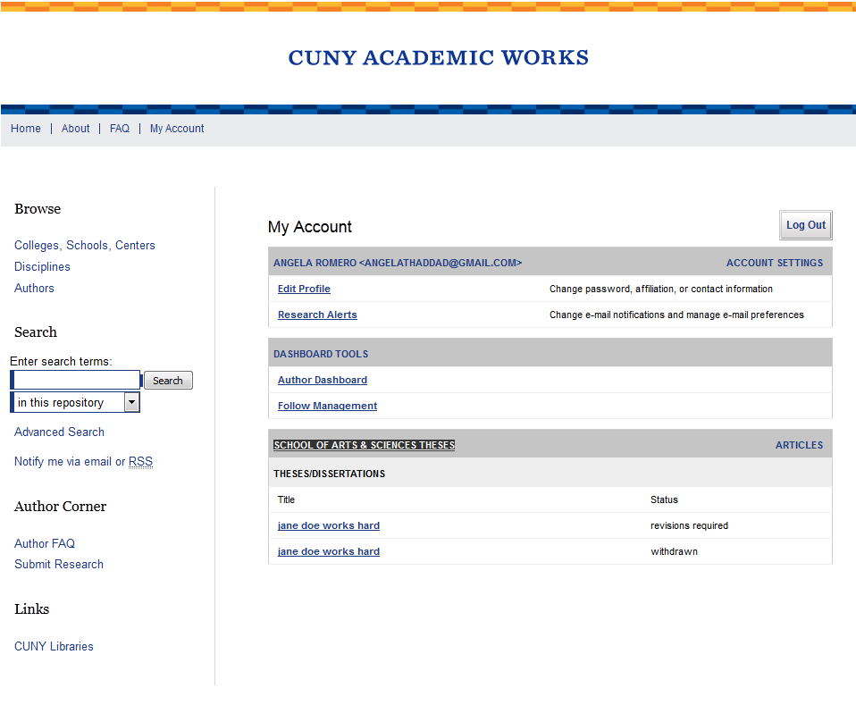
- Read the Submission Agreement and note what you agree to and the items you must have to electronically deposit the thesis:
  - The thesis title page
  - A brief, informative abstract, no more than 50 words (This may be an abbreviated version of the abstract in your thesis.)
  - A list of keywords (10 maximum)
  - An electronic copy of your manuscript submission (PDF or Word) that conforms to the School’s Guidelines For Preparation Of The Master’s Thesis Electronic Submission On CUNY Academic Works.
  - Hyperlinks to files embedded in or as appendices to your thesis.
    - If you upload video to the website, what you put in is what you’ll be able to get out, and we cannot guarantee you’ll be able to open it. While a wide variety of content types of file formats are accepted, consider providing a VIMEO or youtube link to a video.
    - If you are embedding images of others’ works in your thesis, consult with our contact in the Hunter library, Mason Brown, to assure that you are abiding by copyright regulations.
  - Click on the statement at the end of the page indicating you agree to the terms and click submit.
- You will now be on the page to enter your submission. Complete the required items on the form conforming to the following guidelines for the requested entries:
  - For the author, your enter your name and the email address you provided when you created your account.
  - For date of award enter the semester, month, day and year of the thesis deposit deadline. See http://www.hunter.cuny.edu/artsci/graduate-education for the deposit deadline date.
  - For document type select thesis.
  - For degree name, select Master of Arts (MA) or Master of Fine Arts (MFA).
  - For Departments/Program select the name of the academic department for your graduate degree.
  - Language is the language that your thesis is written in and for most, but not all, students will select English.
  - First Adviser is the name of your thesis Chair.
  - You may enter up to three readers/advisers for your thesis. You must enter the names of at least two readers. Any valid email address may be provided for your reader. Ask him/her what email address he/she wishes to use for communications and access to the online repository system.
  - For academic program adviser enter the name of the official graduate adviser for your program.
  - Follow the instructions to select keywords and the subject category. If you need assistance, contact your program adviser or thesis chair.
  - Copy and paste into the space provided an abstract for your thesis. It must be no more than 50 words. Submission with more than 50 words will not be approved by the Dean. The abstract uploaded into the online system may be a condensed version of the abstract included in your thesis.
  - For the EMBARGO PERIOD, you should indicate the length of time that your thesis will not be electronically published on the CUNY Academic Works. We recommend you select “No Embargo Required.” Please consult your program adviser for the other options. If you select any option other than No Embargo, the thesis will still be available in print at the Hunter Library. At the end of the Embargo Period, the work will be posted without notification. You will receive monthly email reports on your submission and this should serve as a reminder of your selected Embargo Period. If you wish to extend the embargo period, you must email the Hunter College administrator, Mason Brown, to make this request.
  - Do Not include any comments in the Comment field.
  - In the field “UPLOAD FULL TEXT,” you will upload you thesis in PDF or Word file format from your computer or drive.
    - To upload your thesis document, select upload file from your computer unless you are uploading from some other web platform.
    - Click on the BROWSE button and select the file that contains the final approved thesis document on your computer.
    - For the requirements on the preparation of the electronic thesis submission request a copy of the “Guidelines for Preparation of the Master’s Thesis, Electronic Submission for CUNY Academic Works” from your program adviser or from Sonia Macias. Thesis that do not follow the guidelines will not be approved by the Dean.
  - If you have appendices or additional files (including images or videos), click the box in the “Additional files field.” You will be prompted to select the additional files.
- When you have successfully completed that required fields and uploaded your thesis, you will see a page to review your submission and information (Metadata). You may revise your submission at this time. Otherwise, the submission will be considered complete.
- Once your submission is complete, you will receive an email notification of the completed submission. Sonia Macias or the Program Administrator for the thesis (PAT) will be notified via email of your submission. Sonia Macias/PAT will send electronic email notifications through CUNY Academic Works to the advisers/readers you listed in your submission form (See item 5g through 5h above).
- Your advisers/readers will receive a system notice advising them to create an account (if they do not have an account) and to review your thesis submission. Once all of your readers and adviser review your thesis, Sonia Macias/Pat will send you an email with a link to their decisions and related comments. See Sample below.
Sonia Macias editor-hc_sas_etds-1012-2086386@dccunyportal.bepress.com
to me, Authors
Dear Ms. Student,
We believe that your thesis/dissertation "jane doe works hard" shows considerable promise. Although we cannot accept it in its current form, we believe that with certain changes we may be able to accept your thesis/dissertation.
[Insert changes here or delete if not required]
To see the reviews, please go to the following page:
http://academicworks.cuny.edu/cgi/preview.cgi?article=1012&context=hc_sas_etds
To submit a revision, use the Revise Submission link on that page.
  - If the email you receive from Sonia Macias/PAT indicates that you must revise and resubmit the thesis, please do so at least 3 days before the School’s deadline for depositing the thesis. If your thesis revisions are not received in a timely manner, your graduation may be delayed. To see the revisions requested by your readers, click on the link sent to you in an email with the decision (see sample email above). This link will take you to the relevant Bepress page. On the section with “REVIEWS”, click on the text for the report of each reader and revise your thesis as requested. Contact your reader or program adviser if you have questions about his/her comments.
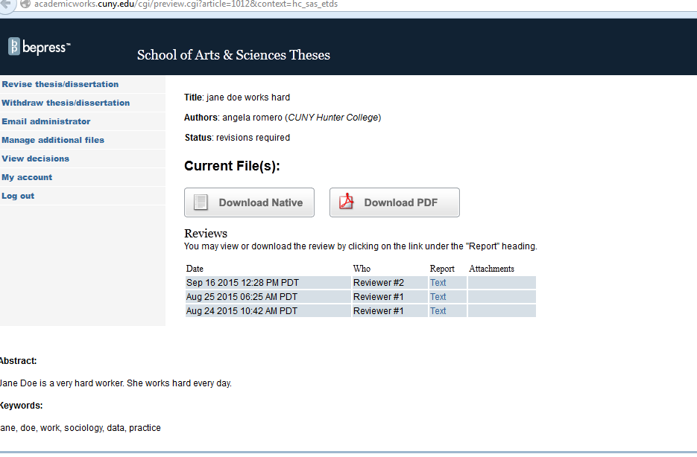

- Dean wi
- To revise the online deposited thesis, use the revision submission link on the left banner of the same page. Depending upon the requested revision, edit the appropriate section and upload a complete thesis file with the revised pages. For example, if you are asked to revise the abstract, do so in that section.
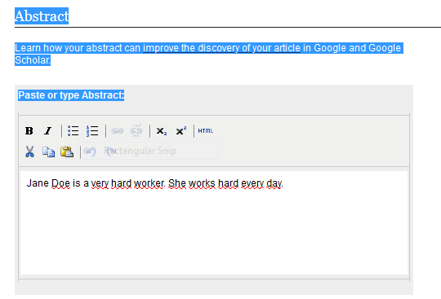
If you must revise the text or other content of the thesis manuscript, upload the entire thesis manuscript with the revised pages, type a reason for submission, and click “SUBMIT.”
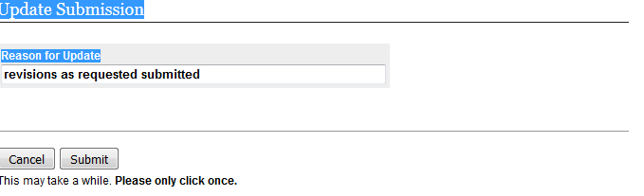
You will receive an email from the system indicating your submission was received. Via email, notify your readers, advisers, and Sonia Macias/PAT that you completed the requested revisions.
- Once the thesis is approved by the adviser, readers, and the dean, it will be posted on CUNY Academic Works unless you embargoed the manuscript. Regardless, you will receive an email from the administrator notifying you of this final action. If, in the rare instance that the readers, adviser, or Dean do not accept your thesis revisions, you will be notified that your thesis deposit has been withdrawn for the semester. In this case, you should contact your graduate program adviser.

Created on August 11, 2015, Revised April 25, 2016

