Effects of the Expanded Child Tax Credit on Employment Outcomes:
Evidence from Real-World Data from January 2021 to February 2022

Elizabeth Ananat^{a,b}, Benjamin Glasnerª, Christal Hamiltonª, Zachary Parolin^{a,c}
ªCenter on Poverty & Social Policy, Columbia University
^{b}Barnard College, Columbia University
^{c}Bocconi University

Abstract

2021’s temporary expansion of the Child Tax Credit (CTC) was intended to reduce child poverty. Simulation studies posit, however, that the payments may lower parent employment, potentially offsetting poverty reduction effects. We empirically test for employment effects using difference-in-differences analyses with Current Population Survey data. Across myriad specifications, including comparisons of those with and without children, of households with different increases in payments, and of households with different changes in the return to work, we find very small, inconsistently signed, statistically insignificant impacts of the CTC on both labor force participation and employment among adults living in households with children.

Acknowledgements: The authors appreciate helpful feedback from Sandra Black, Sophie Collyer, Megan Curran, Irwin Garfinkel, Dan Hamermesh, Rob Hartley, Jane Waldfogel, and Christopher Wimer. We gratefully acknowledge funding from the Annie E. Casey Foundation and The JPB Foundation.

Introduction
From July through December 2021, most households with children in the United States (U.S.) received monthly cash payments of $300 per child under age six and $250 per child between the ages of 6 and 17 under the 2021 American Rescue Plan’s expansion of the existing Child Tax Credit (CTC). The first monthly payment was distributed to households of 59.3 million children in July, while subsequent payments reached more than 61 million children (U.S. Department of Treasury, 2021). Early assessments of the expanded CTC payments suggest they increased low-income households’ spending on food items (Perez-Lopez, 2021), strongly reduced child poverty rates (Parolin, Collyer, Curran, & Wimer, 2021), and strongly reduced food insufficiency (Parolin, Ananat, Collyer, Curran, & Wimer, 2021). Recent empirical research has had less to say, however, on the expanded CTC’s effects on employment outcomes (one exception being Roll, Hamilton, & Chun, 2021).
Economic theory predicts competing effects of the expanded CTC on parental labor force participation and employment. On one hand, the elimination of the phase-in portion of the previous CTC raises incomes while lowering the return to work, which could reduce parental labor force participation and employment. As we discuss below, most simulations of the CTC’s effects thus assume some negative employment effects, although of varying magnitudes (Bastian, 2022; Corinth, Stadnicki, Meyer, & Wu, 2021; Goldin, Maag, & Michelmore, 2021; National Academies of Sciences, Engineering, and Medicine, 2019). On the other hand, eliminating the phase-in, and therefore providing cash to families that are not working, may provide credit-constrained parents with resources to address barriers to employment, such as by allowing them to secure childcare or get auto repairs, which could increase labor force participation and employment. Rachidi (2021), for example, finds that 5 percent of monthly CTC recipients report that the extra income helped them work more, compared to an equivalent share (5 percent) who say that the CTC helped them work less. Similarly, data from the Census Household Pulse Survey suggest that more than 10 percent of CTC recipients have used the funds for childcare expenses (Roll, Hamilton, & Chun, 2021). Moreover, increased aggregate demand as a result of higher incomes, particularly among populations such as low-income families with children that have a high marginal propensity to consume, may have positive macroeconomic effects that contribute to higher aggregate employment (Fisher, Johnson, Smeeding, & Thompson, 2020).
In recent simulation work, scholars have modeled the potential employment effects of the fully-refundable CTC and, in doing so, have made varying predictions. The National Academies of Sciences, Engineering, and Medicine (2019) report on cutting child poverty in half suggested that a child allowance similar to the expanded CTC might reduce employment by 150,000 workers. Focusing on the parameters of the version of the monthly CTC as implemented, Goldin, Maag, and Michelmore (2021) likewise predicted small employment responses. Brill et al. (2021) predicted a decline of 296,000 full-time equivalent jobs. Bastian (2022) predicted that 413,000 adults would stop working. Corinth, Stadnicki, Meyer, and Wu (2021) predicted that the expanded CTC would lead 1.5 million working parents (2.6 percent of all working parents) to exit the labor force. The differences in the simulations are driven by different assessments regarding the proper size and the types of employment elasticities applied in the models.
This study diverges from the simulation approach and the related debate over the assumed size of employment elasticities; we instead build on earlier work by empirically assessing the employment effects of the expanded CTC using available data pre- and post-expansion. Specifically, we apply a series of difference-in-differences analyses using data from the monthly Current Population Survey files from January 2021 through February 2022. We leverage: variation in policy eligibility between households with children and those without; in CTC payment amount received by households based on the ages of children, the number of children, and pre-reform income levels; and variation in the implied change in the effective tax rate on work faced by the household as a function of the change in the CTC’s structure.
Across these model specifications and many robustness checks, we find very small, statistically insignificant, and inconsistently signed impacts of the CTC on employment in the prior week and on being active in the labor force. Findings are similar when evaluating heterogeneous effects across income levels and demographic subgroups. The short-term consequences of the CTC for employment, estimated using real-world outcomes, are not consistent with simulations that suggest that the CTC’s long-run employment effects will meaningfully offset its observed reductions in poverty and hardship. They are, however, consistent with other real-world evaluations of the 2021 CTC expansion showing declines in poverty and food insufficiency in households with children.
We acknowledge that long-run employment effects, should the program be made permanent, could be different from those observed in 2021. However, under neoclassical assumptions, basic price theory implies that the temporary nature of the 2021 program, along with other exceptional features of the 2021 labor landscape, make the effects of the 2021 expansion a lower bound for any negative labor supply effects of a permanent expansion (i.e., an upper bound for the absolute value of the effect). That is, if neoclassical assumptions hold, any long-run labor supply effects from a permanent policy change should be more muted than the short-term effects we observe from a temporary change.

Policy Context
Prior to the expanded CTC, tax filers could receive a maximum CTC of $2,000 per child per year, but many children did not receive the full refundable amount. The CTC credit phased in at a rate of 15 cents per dollar of earnings and was only partially refundable to those who did not on net owe federal income tax, providing an effective wage subsidy but denying benefits to those with low or no earnings. As a result, one in three children did not receive the full benefit value because their families did not earn enough income to qualify. Children with single parents, those in rural areas, Black and Latino children, and those in larger families were disproportionately ineligible for the full credit (Collyer, Harris, & Wimer, 2019; Curran & Collyer, 2020).
Following parameters similar to the American Family Act (a bill first introduced in both the Senate and House of Representatives in 2017 and reintroduced in 2019), the American Rescue Plan (ARP) temporarily transformed the CTC into a nearly-universal child allowance for 2021. Specifically, the ARP included three fundamental changes to the CTC. First, it made the CTC available to almost all children—including those previously excluded due to their families’ low income—by removing the earnings requirement and making the credit fully refundable. Second, it raised the maximum annual credit amount to $3,000 for children ages 6–17 and $3,600 for children under age six. Third, beginning mid-July 2021, the ARP delivered the credit in monthly installments of up to $250 per older child or up to $300 per child under six years of age, for a period of six months. The IRS reported delivering the first payment to families of 59.3 million children in July, while subsequent payments reached more than 61 million children. In the Census Pulse Household Survey, the majority of parents (67%) reported receiving the payments, although rates were lower among low-income families and Asian and Hispanic families (see Figures A1 and A2); however, concerns about representativeness in the Pulse (Bradley et al. 2021) and about general underreporting of government benefits (Meyer et al. 2015) imply that these reports represent underestimates of actual receipt.
While the ARP enacted a variety of economic supports, many of those (general stimulus payments, Unemployment Insurance supplements) affected households with and without children. Moreover, the CTC was the only program that provided payments solely in the months of July through December 2021. Using the specific off-on-off structure of the CTC payments and households without children as control groups, along with other approaches that exploit non-linear differences between families in the amount received, allows us to isolate the effect of the CTC from other programs.
Early research suggests that the expanded CTC generated large reductions in child poverty (Parolin, Collyer, et al., 2021), reduced food insufficiency among households with children (Parolin, Ananat, et al., 2021), increased spending on childcare (Roll, Hamilton, & Chun, 2021), and helped as many working parents to “work more” as to “work less” (Rachidi, 2021). Although economic theory largely predicts, and has often demonstrated, that an unconditional cash transfer can lead to employment declines, recent studies evaluating similar child benefit programs in Canada—the Canadian Universal Child Care Benefit (UCCB) and the Canada Child Benefit (CCB)—found no evidence of a labor supply response (Baker, Messacar, & Stabile, 2021).
For that reason, recent research simulating the effects both of a permanent child allowance (National Academies of Sciences, Engineering, and Medicine, 2019) and of a permanent version of the 2021 CTC expansion (Corinth et al., 2021) has modeled the income elasticity of parent labor supply with respect to the transfer as zero. However, differences in assumptions about the price elasticity of parent labor supply—relevant because of the expansion’s erasure of the previous phase-in range of the credit, which eliminated a wage subsidy for relatively low-earning parents—led to different predictions about the effects of this expansion on parent employment, with Corinth et al. (2021) suggesting employment declines that range from 150,000 adults to 1.5 million adults.
Rather than projecting future employment losses, this study empirically investigates real-world data to assess whether the temporary CTC expansion had a plausibly causal effect on parents’ labor market engagement during its installments of six monthly payments in 2021. While these estimates reflect the effects of a temporary, rather than permanent, policy change, the effects of a temporary cut in the return to work on labor supply provide a lower bound for any negative effects of a permanent change in a neoclassical model (in a neoclassical model, the theoretical upper bound is zero). Holding the income elasticity of parent labor supply at zero, as is now conventional in the literature, means that only the compensated price elasticity is at play. Compensated intertemporal labor supply elasticities will be larger in absolute value in response to temporary wage changes than in response to permanent wage changes, due to incentives for re-timing (see, e.g., Biddle, 1988). That is, the policy provides a time-limited opportunity for a non-work spell at a lower price than usual, which will cause a much larger share of parents to re-time a desired non-work spell toward the low-price period than would take time out of the labor force in any given period if the price were permanently lowered (in the same way that a time-limited sale on any good with a negligible income share will lead to a larger per-period increase in consumption than would a permanent price cut).
In addition, there are several reasons parents would have been more likely to substitute away from employment during 2021 than they might be in more typical times. First, the threat of COVID temporarily increased the cost to many Americans of working, particularly in the public-facing roles most often available to the low-wage workers most affected by the elimination of the phase-in. Second, child care and school continued to be unpredictable in the second half of 2021, again making work temporarily less feasible and attractive for parents. Third, continuing worker shortages over the period implied parents would be able to find jobs in 2022 if they took time off in 2021, temporarily lowering the opportunity cost of delayed job matching. All of these factors increased parents’ incentives to re-time non-work spells toward late 2021 in response to the temporarily lower cost of such spells. Even if only some parents perceived the change in CTC as temporary, while others perceived it as permanent, the aggregate decline in employment should still provide a lower bound for the aggregate decline under an announced permanent CTC change. Thus, empirical estimates of the effects of the temporarily expanded 2021 CTC on parental employment provide a lower bound for any parental employment declines under a permanently expanded CTC given strict neoclassical assumptions.
Relaxing neoclassical assumptions allows for the possibility that the temporary change in incentives in the 2021 CTC were not fully understood–if it takes time for parents to learn about reduced work incentives, then labor supply responses to a short-term change may not in fact represent a lower bound for long-term negative responses to an announced permanent change. Evidence from expansions of the Earned Income Tax Credit suggests that labor supply responses may evolve over several years, while evidence from the previous form of the CTC suggests that parents may misperceive changes in average tax rates for changes in marginal tax rates, even in the long run (Feldman et al. 2016). Of course, relaxing neoclassical assumptions also allows other possible effects. In particular, if poor parents are liquidity-constrained from making work investments, as in the canonical model of the poverty trap, then a universal CTC could, in the long run, actually increase parent labor supply. Such a possibility is consistent with Rachidi’s (2021) finding that 5 percent of parents reported that the expanded CTC helped them work more.

Data and Methods

Data
This study uses data from the Current Population Survey (CPS). The CPS is a nationally representative monthly household survey conducted jointly by the U.S. Census Bureau and the Bureau of Labor Statistics. As the primary source of employment statistics for the US population, the CPS gathers data on labor force participation and demographics in its basic monthly survey, and it gathers additional information in its Annual Social and Economic Supplement (CPS ASEC). We use data from January 2021 through February 2022 basic monthly surveys and from the 2019 ASEC. We exclude the month of July 2021, given that we cannot distinguish pre-treatment versus post-treatment responses within July. Recent work (Ward and Edwards 2021) has raised concerns about CPS nonresponse during the first months of the pandemic due to the switch away from in-person interviewing. However, our data focus on 2021 and 2022, during which traditional interviewing had resumed and participation had rebounded, although it remained slightly below its pre-pandemic level.

Sample
We limit our primary sample to adults between the ages of 18–65 years old. Our pooled CPS monthly sample includes 882,732 adults. Descriptive statistics are shown in Table 1. The monthly CPS does not gather information on CTC receipt. We therefore code a household as eligible for receiving CTC payments in the CPS if they had at least one child present in the household, and as ineligible if there was no child present. All estimates therefore reflect intent-to-treat effects.

Measures
Outcomes
We investigate the impact of the CTC expansion on the extensive margin of the supply of labor using both employment status, as measured by an indicator variable for employment at the time of the interview, and whether adults were members of the labor force in the week prior to their CPS interview.
Subgroups
We also conduct subgroup analyses. First, we define pre-expansion household income subgroups using a categorical income variable that includes “money from jobs, net income from business, farm or rent, pensions, dividends, interest, social security payments, and any other money income received” among household members in the prior year. We also define demographic subgroups by education, gender, and marital status.

Analytical Strategy
To assess the effect of the CTC on the labor market outcomes, we employ difference-in-differences models using the following equation:
$y_{it}={β_{1}DurCTC}_{t}+β_{2}{Treatment}_{i}+β_{3}{\left(DurCTC*Treatment\right)}_{it}+ {β_{4}X}_{i}+ +ε_{it}$ (1)
where y_{it} is one of our two outcomes of interest (employment status; labor force participation). DurCTC is a binary indicator of whether the time of the survey was between July 2021 and December 2021, the time during which the expanded CTC’s monthly checks were administered. X is a vector of household head characteristics—age (measured continuously), sex (equal to one if male), and educational attainment (indicators for high school or less, some college, or a bachelor’s degree or more)—and both state and month fixed effects. We report robust standard errors clustered at the state level, which leads our estimated standard errors, particularly in our subgroup analyses, to be quite large (even while point estimates remain close to zero), consistent with Abadie et al.’s (2022) recent conclusion that “when the number of clusters in the sample is a nonnegligible fraction of the number of clusters in the population, conventional clustered standard errors can be severely inflated." We opt to cluster standard errors in this way in order to be conservative about the effect sizes we can rule out.
We specify our treatment variable, Treatment, in three separate ways. In our first specification, we operationalize a binary treatment indicator that is equal to one if a household had children and set to zero if no child was present in the household. In our second specification, we estimate models using a continuous measure of treatment intensity to capture the fact that the effects of the CTC are likely to vary by the age of children (as families with children under age six receive larger monthly benefit values), the number of children in the home, and the relative value of the new CTC benefits compared to what the household likely received from the CTC prior to the reform. Because we do not have information on pre-reform CTC receipt, we use data from the 2019 U.S. Current Population Survey Annual Social and Economic Supplement (CPS ASEC) to estimate the mean pre- and post-reform benefit values for bins defined by the number of adults in the household (ranging from 1 to 10), the number of children in the household (ranging from 0 to 10), and eight categorical pre-tax income bins (from under $25,000 annually scaling up to more than $200,000 per year). We compute the mean pre-reform refundable CTC benefits as observed for each family unit within a household in the CPS ASEC. We then simulate the additional post-reform benefits that each family is eligible for using detailed policy rules from the CTC reform as specified in the 2021 American Rescue Plan. We subtract the pre-reform benefit value from the post-reform benefit value to create a “net benefit” indicator for each family unit. Finally, we calculate the weighted mean of the net benefit value for each of the household-level bins defined above. We then import this value into our monthly CPS data, matching on the number of adults, number of children, and total household income of respondents.
In our third specification, we calculate the change in after-tax income from work with the expanded CTC, relative to after-tax income from work under the previous design of the CTC, in order to reflect the change in the return to work faced by a household as suggested by Corinth et al. (2021). First, we estimate the expected income tax liability after accounting for the standard deduction of each respondent, given household income bin, marital status, and number of children. We then use this remaining tax liability and net out the value of the previous CTC they would have received in the absence of the expansion. For those respondents who have a tax liability greater than their old CTC, they would have received the full payment. For respondents who would have qualified for a CTC payment greater than their remaining tax liability, they would have received a payment up to their estimated remaining tax liability. We then divide their earnings by the sum of their earnings and the CTC payment they would have received based on their earnings, and subtract this number from 1 to get the percent decrease in the return to work due to the elimination of the phase-in. Figure 1 displays the mean percent change in the return to work (top panel) and mean net gain in CTC benefits (bottom panel) by income bin and number of children.
In each model, β₃ is our primary coefficient of interest, as it identifies, when using the binary treatment indicator, whether adults in households with children were more or less likely to be engaged in the labor market relative to adults in childless households after the introduction of the CTC changes. When using the continuous dollar treatment, it represents the effect of eligibility for an additional $100 per month in increased net benefits on labor market engagement. When using the third specification, it represents the effect of a given percent change in the return to work on labor market engagement.
In addition to our main analytical specifications, we also estimate effects separately for households in different pre-period annual income bins, from less than $25,000 to over $200,000 in total household income, and for households in different demographic subgroups. In a series of robustness checks, we: re-specify the post-treatment date as the time of the CTC expansion’s passage; check for seasonality; exclude repeated household observations in the CPS; conduct an event study; and execute Callaway-Sant’Anna estimates using, alternately, size of payment, number of children, and change in the return to work.

Findings

Descriptive Findings
Figure 2 shows the trend in employment and labor force participation from January 2021 to February 2022 using the monthly CPS. This window is in the middle of the COVID-19 pandemic and begins after the initial macro-level drop in employment and participation. Each point represents the weighted average employment rate or the labor force participation rate among respondents between the ages of 18 and 65. These results are split by whether the respondent reported at least one child in the household and by pre-period income.
Figure 2 highlights the baseline difference in labor market engagement between adults in households with and without children, wherein adults in households with children tended to have higher and more stable levels of employment and labor force participation throughout this sample window. Nevertheless, in all three income bins, employment and labor force participation rates among adults in households with children trended similarly to rates among adults in childless households in the pre-period from January to July 2021.

Estimation Results
Table 2 presents the results from difference-in-differences estimates using data from the CPS for the periods January 2021 through February 2022 (left panel) and January 2021 through December 2021 (right panel). We present estimated effects on employment in odd columns and on labor supply in even columns. The top panel provides estimates from models using our binary treatment measure; the bottom panel provides estimates from our continuous treatment measure.
Our results suggest, in short, that the CTC expansion had no significant impact on employment outcomes. Specifically, estimated effects using the binary model of treatment in the CPS for our full data (January 2021–February 2022) show that relative to adults in childless households, adults in households with children had a statistically insignificant 0.2 percentage point drop in employment (s.e.=0.4 percentage points) and a statistically insignificant 0.0 percentage point decrease in labor force participation (s.e.=0.3 percentage points) during CTC expansion. Estimates using data from January 2021 through December 2021 show that relative to adults in childless households, after CTC expansion adults in households with children had a statistically insignificant 0.0 percentage point increase in employment (s.e.=0.5 percentage points) and a statistically insignificant 0.2 percentage point increase in labor force participation (s.e.=0.4 percentage points).
Using the predicted increase in credit size—capturing variation based on pre-tax income and household size—using data through February 2022, we find that an additional $100 in monthly CTC led to a statistically insignificant 0.1 percentage point increase in employment (s.e.=0.1 percentage points) and a statistically insignificant 0.1 percentage point increase in labor force participation (s.e.=0.1 percentage point). For a family with two children whose credit rose by a typical $300 per month, this would imply a 0.3 percentage point increase in employment and participation and a 95% confidence interval of -0.3 to 0.6 percentage point change. For our models using data through December 2021, an additional $100 in CTC led to a statistically insignificant 0.1 (s.e.=0.1 percentage point) and 0.2 (s.e.=0.2 percentage points) percentage point increase in employment and labor force participation respectively.
Using the predicted change in the return to work—presented in Table 3—in the CPS we find that a 1% increase in the return to work led to a statistically insignificant .04 percentage point increase in employment, suggesting that the CTC expansion would lead to an insignificant decrease in work for those who experienced a decline in the return to work; a 1% increase in the return to work also led to a .02 percentage point decrease in labor force participation, suggesting that the CTC expansion would lead to an insignificant increase in participation among those who experienced a decline in the return to work (s.e.=.06 percentage points for both). For a family with two children facing a typical 4% decline in the return to work, this would imply a .16 percentage point decrease in employment and a .08 percentage point increase in labor force participation (95% confidence intervals of -.40 to .08 percentage point change in employment and -.16 to .32 percentage point change in participation).
Figure 3 visualizes the effect of the CTC on employment outcomes across the income distribution using the CPS and Pulse data respectively. Each point in Figure 3 represents the coefficient from the interaction terms for our binary treatment (black circle) and $100s of net increased benefits per month treatment (dark gray triangle) when subsetting the sample to only include households with total incomes under $25,000, between $25,000 to $35,000, $35,000 to $50,000, $50,000 to $100,000, and $100,000 to $200,000. Figure 3 highlights the insignificant and inconsistently signed relationship between the CTC expansion and both employment and participation across the income distribution, using data from the CPS from January 2021 through February 2022 and our binary and continuous treatment measures. Notably, we find neither significant differences between the effects of expansion on the lower income groups and higher income groups nor a consistent gradient of point estimates (point estimates are small and, moreover, a mix of positive and negative), which would be indicated by the elasticity assumptions that drive previous simulation-based predictions of labor force decline. However, standard errors mechanically increase with subgroup analysis, which moderates our ability to draw strong conclusions from these results, particularly using our binary treatment definition; we are unable to rule out effects as large as a 3% decline in employment and a 3% increase in participation for those earning $25,000-$35,000 under the binary specification.
In Figure 4, we present heterogeneous effects of CTC expansion by demographic groups. Again, we find insignificant and inconsistently signed relationships between CTC expansion on employment and labor force participation when using our binary and continuous treatment measures. Among single mothers with low formal education, a group whose work effort policymakers often emphasize, point estimates, while insignificant, are large and positive. Again, however, standard errors mechanically increase with subgroup analysis, which moderates our ability to draw strong conclusions from these results; we are unable to rule out effects as large as a 3.5% decline in employment and participation for mothers with a high school degree and as large as a 6% increase for single mothers with a high school degree.

Robustness Checks
In Table 4, we present alternative models using March 2021, the month when the policy was introduced (but before CTC payments were distributed), as our treatment timing; Corinth et al. (2021) argue that parents will respond to the change in 2021 work incentives beginning with the law’. Similar to our actual estimates, we find small and insignificant effects that suggest that parents did not respond to the announcement of the policy by reducing their labor supply. In Table 5, we re-run our main specifications on 2020 CPS data (using July 2020-December 2020 as the treatment months) to assess the possibility that seasonality that might otherwise have caused changes between our treatment and control groups during this period muted the effects of the policy; the null results we find suggest that this is not the case.
Figure 5 presents the event study using the binary definition of treatment and either the July (red triangles) or March (blue circles) definition of treatment start date. There is no evidence of a pre-period trend, and 47 of the 48 point estimates are insignificantly different from zero.
In Table 6, we re-run our main specifications but fully interact all measures with time and treatment group indicators. In Table 7, we re-run our main specifications while excluding observations of adults in households with children who are not parents of a child in the household. In Table 8, we re-run our main specifications while excluding repeated observations of the same household in the CPS. In Table 9 we re-run our main specifications including state-month varying controls for COVID death rate and unemployment rate, and the interactions of those with treatment status (both binary and continuous). In all cases estimates remain stable, with a mix of small positive and small negative point estimates and standard errors that grow somewhat with the number of controls.
We also include Callaway and Sant’Anna (2021) estimates, to address concerns (Borusyak, Jaravel & Spiess, 2021; Callaway & Sant’Anna 2021; Goodman-Bacon, 2021; Sun & Abraham, 2021) that the two-way fixed effects estimator reports a weighted average treatment on the treated estimate across treatment groups because treatment size varies across households, and that when using a continuous treatment, the comparison groups become more difficult to identify (Callaway, Goodman-Bacon, & Sant’Anna, 2021). Figures 6 through 8 present results from our analyses using the Callaway and Sant’Anna (2021) estimator. The Callaway-Sant’Anna approach requires splitting the sample into very small subsamples, necessarily decreasing precision, and so standard errors mechanically increase. However, the purpose of Callaway-Sant’Anna estimates is not to create bounds on the overall effects, since that is accomplished through estimates that pool all our observations; rather, it is a validity check that tests whether, in a continuous treatment, there are different marginal effects at different points in the treatment distribution.
We do not find evidence that effects differ, either statistically, given the standard errors, or economically, given the small and stable point estimates. The estimates reveal no evidence of an effect of the CTC expansion on employment or labor force participation; moreover, when exploring the CTC expansion by groups, we find no evidence of significant deviation from the aggregate result, including when comparing estimates for households who had larger payment increases or larger decreases in the return to work with those for households with smaller changes. These results are in line with results from our main analytical specification: the CTC expansion did not appear to affect parents’ employment or labor force participation regardless of household composition, change in payment size, or change in the return to work.
In the Appendix, we present parallel results for our main specifications from the Census’s Household Pulse Survey. Because of concerns about representativeness in the Pulse given its low response rate (Bradley et al. 2021), we view these analyses solely as supporting evidence. Estimates are substantially similar.

Discussion and Conclusion
The temporary expansion of the Child Tax Credit in July 2021 into a more generous and inclusive monthly payment represented a large deviation from the direction of the U.S. welfare state throughout the past three decades. Recent studies have shown that the CTC expansion reduced poverty rates (Parolin, Collyer, et al., 2021) and food insufficiency (Parolin, Ananat, et al., 2021) among households with children. Some researchers, however, suggest that the expansion could generate negative employment effects. While recent simulation research has reached varying conclusions—with some scholars predicting negligible negative effects and others significant reductions in labor force participation—little research to date has empirically evaluated the impact of the CTC expansion on employment outcomes using real-world data.
This study uses nationally-representative data covering the six months of payments (January 2021 to February 2022) to assess the effect of the expanded CTC on labor outcomes among households with children. To identify policy effects, we implemented a series of difference-in-differences models leveraging the variation in policy eligibility and the structure of CTC payment amounts. In addition to our main analytical specification, we also estimated effects separately for households in different pre-period annual income bins, from less than $25,000 to $100,000-$200,000 in total pre-period household income, and by demographic group.
Our analyses reveal that the CTC expansion had no meaningful impact on employment and labor force participation after six months of benefit distribution. We find statistically insignificant, inconsistently signed differences in employment and labor force participation among adults in eligible households in the six months of the CTC expansion. A variety of robustness checks also consistently show insignificant effects on employment and labor force participation.
Results from analyses exploring heterogeneity across income groups also reveal that the CTC expansion had no significant effect on employment and labor force participation for lower-income groups, which benefited most from the CTC expansion and also faced larger decreases in the return to work. Of note, we find no significant differences in policy effects between lower- and higher-income groups.
Evidence from a temporary change in the cost of non-employment, given the scholarly consensus (upheld here in our benefit increase specification) that the income effect of the CTC on parent employment is zero, should, under neoclassical assumptions, provide a lower bound for any negative effect of a permanent expansion of the CTC on employment. Evidence that even the temporary wage cut in the 2021 CTC expansion did not reduce parent employment thus strongly suggests that a permanent expansion would not meaningfully reduce parent employment. If neoclassical assumptions are relaxed, then it is possible that learning over time about the change in work incentives from the elimination of the credit phase-in would instead cause larger long-term declines from a permanent expansion than we estimate here–but then it is also possible that a permanent expansion, by relaxing credit constraints for families currently unable to make work investments, would instead lead to higher parent employment in the long run.
Our analysis has limitations. First, the CPS suffered a decrease in response rates at the start of the pandemic, which had partially but not fully abated by the time the data used in our study were collected; it is possibly that responses analyzed here are not fully representative of the affected population. Second, while our point estimates are generally small and inconsistently signed, our standard errors increase as we add model restrictions, which is partially an artifact of our conservative decision to cluster our standard errors at the state level, despite the recent caution of Abadie et al. (2021) that in circumstances such as ours this can lead calculated standard errors to be “severely inflated.” Given these conservative choices, under some specifications we are unable to rule out economically meaningful effects (both positive and negative) of the CTC expansion on labor supply with 95% confidence.
We conclude that real-world data on employment during the temporary CTC expansion do not support claims that the benefit itself or its elimination of the phase-in portion of the CTC discouraged work among parents in any meaningful way, much less that such effects are large enough to offset decreases in poverty and material hardship driven by the expansion’s increased generosity and inclusivity. Our results are, instead, consistent with other real-world analyses of the expansion’s effects, which show observed declines in child poverty (Parolin, Collyer, et al., 2021) and strongly reduced food insufficiency (Parolin, Ananat, et al., 2021). Our results suggest that the mechanism through which these reductions occurred is that the increase in income that was both intended and accomplished through the expansion, combined with a lack of unintended effects on parental work, led to improved well-being for households with children.

References
Abadie, A., Athey, S., Imbens, G. W., Wooldridge, J. M. (2023) “When Should You Adjust Standard Errors for Clustering?” The Quarterly Journal of Economics, 138(1):1–35, https://doi.org/10.1093/qje/qjac038
Baker, M., Messacar, D., & Stabile, M. (2021). The effects of child tax benefits on poverty and labor supply: Evidence from the Canada Child Benefit and Universal Child Care Benefit (No. w28556). National Bureau of Economic Research.
Bastian, J. (2022). How Would a Permanent 2021 Child Tax Credit Expansion Affect Poverty and Employment? Retrieved from https://drive.google.com/file/d/1H5iNZZO_YFRIDz-3Tip4C-BpnD85bUjH/view
Bauer, L., Schanzenbach, D. W., & Shambaugh, J. (2018). Work requirements and safety net programs. The Hamilton Project.
Biddle, J.E. (1988). Intertemporal substitution and hours restrictions, The Review of Economics and Statistics, MIT Press 70(2), 347-351.
Bitler, M., Hoynes, H. W., & Schanzenbach, D. W. (2020). The social safety net in the wake of COVID-19 (No. w27796). National Bureau of Economic Research.
Borusyak, K., Jaravel, X., & Spiess, J. (2021). Revisiting event study designs: Robust and efficient estimation. arXiv preprint arXiv:2108.12419.
Bradley, V.C., Kuriwaki, S., Isakov, M. et al. Unrepresentative big surveys significantly overestimated US vaccine uptake. Nature 600, 695–700 (2021). https://doi.org/10.1038/s41586-021-04198-4.
Brill, A., Pomerlau, K., & Seiter, G. (2021). Model introduction: Estimating the labor supply response to a permanent Child Tax Credit expansion. Retrieved from https://grantseiter.com/CTC-Labor-Response/intro.html
Cai, C., Woolhandler, S., Himmelstein, D. U., & Gaffney, A. (2021). Trends in anxiety and depression symptoms during the COVID-19 pandemic: Results from the US Census Bureau’s Household Pulse Survey. Journal of General Internal Medicine, 36(6), 1841-1843.
Callaway, B., Goodman-Bacon, A., & Sant'Anna, P. H. (2021). Difference-in-differences with a continuous treatment. arXiv preprint arXiv:2107.02637.
Callaway, B., & Sant’Anna, P. H. (2021). Difference-in-differences with multiple time periods. Journal of Econometrics, 225(2), 200-230.
Collyer, S., Harris, D., & Wimer, C. (2019). Left behind: The one-third of children in families who earn too little to get the full Child Tax Credit. Poverty & Social Policy Brief, 3(6).
Corinth, K., Stadnicki, M., Meyer, B. D., & Wu, D. (2021). The anti-poverty, targeting, and labor supply effects of the proposed Child Tax Credit expansion. University of Chicago, Becker Friedman Institute for Economics Working Paper, No. 2021-115.
Crandall-Hollick, M. L. (2018). The Child Tax Credit: Current Law. CRS Report R41873. Washington, DC: Congressional Research Service
Crandall-Hollick, M. L. (2021). The Child Tax Credit: Proposed expansion in the American Rescue Plan Act of 2021 (ARPA; H.R. 1319). CRS Report IN11613. Washington, DC: Congressional Research Service
Curran, M. (2015). Catching up on the cost of raising children: Creating an American child allowance. In Big Ideas: Pioneering Change, Innovative Ideas for Children and Families. Washington DC: First Focus.
Curran, M., & Collyer, S. (2020). Children left behind in larger families: The uneven receipt of the federal Child Tax Credit by children’s family size. Poverty & Social Policy Brief, 4(4). Retrieved from https://static1.squarespace.com/static/5743308460b5e922a25a6dc7/t/5e605fe34cbc0979d6dd5ac8/1583374310078/Child-Tax-Credit-Larger-Families-CPSP-2020.pdf
Feldman, N. E., Katuščák, P., & Kawano, L. (2016): “Taxpayer confusion: Evidence from the child tax credit,” American Economic Review, 106, 807–35.
Fisher, J. D., Johnson, D. S., Smeeding, T. M., & Thompson, J. P. (2020). Estimating the marginal propensity to consume using the distributions of income, consumption, and wealth. Journal of Macroeconomics, 65, 103218.
Garfinkel, I., Harris, D., Waldfogel, J., & Wimer, C. (2016). Doing more for our children: Modeling a universal child allowance or more generous child tax credit. New York: The Century Foundation.
Goldin, J., Maag, E., & Michelmore, K. (2021). Estimating the net fiscal cost of a Child Tax Credit expansion. NBER Chapters.
Goodman-Bacon, A. (2021). Difference-in-differences with variation in treatment timing. Journal of Econometrics, 225(2), 254-277.
Hoynes, H. (2019). The earned income tax credit. The Annals of the American Academy of Political and Social Science, 686(1), 180-203.
Meyer, B. D., Mok, W., and Sullivan, J. X. (2015). "Household Surveys in Crisis." Journal of Economic Perspectives, 29 (4): 199-226.
Morales, D. X., Morales, S. A., & Beltran, T. F. (2020). Racial/ethnic disparities in household food insecurity during the COVID-19 pandemic: a nationally representative study. Journal of Racial and Ethnic Health Disparities, 1-15.
National Academies of Sciences Engineering and Medicine. (2019). A roadmap to reducing child poverty. Washington, DC: National Academies Press
Pac, J., Nam, J., Waldfogel, J., & Wimer, C. (2017). Young child poverty in the United States: Analyzing trends in poverty and the role of anti-poverty programs using the Supplemental Poverty Measure. Children and Youth Services Review, 74, 35-49.
Parolin, Z., Ananat, E., Collyer, S. M., Curran, M., & Wimer, C. (2021). The initial effects of the expanded Child Tax Credit on material hardship (No. w29285). National Bureau of Economic Research.
Parolin, Z., Collyer, S., Curran, M., & Wimer, C. (2021). Monthly poverty rates among children after the expansion of the Child Tax Credit. Poverty & Social Policy Brief 5(4). Retrieved from https://www.povertycenter.columbia.edu/s/Monthly-Poverty-with-CTC-July-CPSP-2021.pdf
Perez-Lopez, D. (2021). Economic hardship declined in households with children as Child Tax Credit payments arrived. U.S. Census Bureau. Retrieved from https://www.census.gov/library/stories/2021/08/economic-hardship-declined-in-households-with-children-as-child-tax-credit-payments-arrived.html
Rachidi, A. (2021). New survey data raises questions about the expanded Child Tax Credit. American Enterprise Institute. Retrieved from https://www.aei.org/poverty-studies/new-survey-data-raises-questions-about-the-expanded-child-tax-credit/
Roll, S., Hamilton, L., & Chun, Y. (2021). Expanded Child Tax Credit payments have not reduced employment. Evidence from Census data. Retrieved from https://cpb-us-w2.wpmucdn.com/sites.wustl.edu/dist/a/2003/files/2021/10/CTC-and-Employment-10212021.pdf.
Schanzenbach, D., & Pitts, A. (2020). Food insecurity in the census household pulse survey data tables. Institute for Policy Research, 1-15.
Shaefer, H. L., Collyer, S., Duncan, G., Edin, K., Garfinkel, I., Harris, D., . . . Yoshikawa, H. (2018). A universal child allowance: A plan to reduce poverty and income instability among children in the United States. RSF: The Russell Sage Foundation Journal of the Social Sciences, 4(2), 22-42.
Shaefer, H. L., & Edin, K. (2013). Rising extreme poverty in the United States and the response of federal means-tested transfer programs. Social Service Review, 87(2), 250-268.
Sun, L., & Abraham, S. (2021). Estimating dynamic treatment effects in event studies with heterogeneous treatment effects. Journal of Econometrics, 225(2), 175-199.
Twenge, J. M., & Joiner, T. E. (2020). US Census Bureau‐assessed prevalence of anxiety and depressive symptoms in 2019 and during the 2020 COVID‐19 pandemic. Depression and Anxiety, 37(10), 954-956.
U.S. Department of Treasury. (2021). Treasury and IRS announce families of nearly 60 million children receive $15 billion in first payments of expanded and newly advanceable Child Tax Credit [Press release]. Retrieved from https://home.treasury.gov/news/press-releases/Treasury-and-IRS-Announce-Families-of-Nearly-60-Million-Children-Receive-%2415-Billion-Dollars-in-First-Payments-of-Expanded-and-Newly-Advanceable-Child-Tax-Credit
Ward, J., & Edwards, K. A. (2021). “CPS Nonresponse During the COVID-19 Pandemic: Explanations, Extent, and Effects.” Labour Economics, https://doi.org/10.1016/j.labeco.2021.102060
Ziliak, J. P. (2021). Food hardship during the COVID‐19 pandemic and Great Recession. Applied Economic Perspectives and Policy, 43(1), 132-152.

Tables and figures

Table 1: Descriptive Statistics
 | Mean | St. Dev.
Employment rate | 0.710 | -
Labor force participation rate | 0.749 | -
Age | 41.28 | 13.81
Percent female | 0.508 | -
Household size | 3.13 | 1.58
Number of children | 0.728 | 1.09
N | 882,933
Note: Sample: adults between ages 18–65 in the Current Population Survey.

Table 2: Difference-in-Differences Estimates of the Effect of Expanded CTC on Employment Outcomes (Current Population Survey, January 2021 through February 2022)
 | Jan 2021 – Feb 2022  (Treatment Off, On, and Off) |  | Jan 2021 – Dec 2021  (Treatment Off and On)
Binary Treatment | 1: Employed | 2: Active in Labor Force | 3: Employed | 4: Active in Labor Force
Household with Children | 0.043*** | 0.037*** | 0.041*** | 0.035***
 | (0.003) | (0.003) | (0.003) | (0.003)
Household with Children X Treatment Period | -0.001 | 0.001 | 0.000 | 0.002
 | (0.004) | (0.003) | (0.005) | (0.004)
Continuous Treatment | Employed | Active | Employed | Active
Household with Children | 0.000 | 0.000 | 0.000 | -0.000
 | (0.006) | (0.005) | (0.006) | (0.005)
Household with Children X Treatment Period | 0.001 | 0.001 | 0.001 | 0.002
 | (0.001) | (0.001) | (0.001) | (0.001)
Pre-Treatment Mean among Households with Children | 0.728 | 0.769 | 0.728 | 0.769
Observations | 882,933 | 882,933 | 700,597 | 700,597
Note: Sample: adults between ages 18–65. All models include state and month fixed effects and controls for age, education, and sex. Treated period refers to July 15, 2021, through December 31, 2021. Robust standard errors clustered at the state level in parentheses. * p < 0.05, * p < 0.01, *** p < 0.001.
Table 3: Difference-in-Differences Estimates of the Effect of the Change in Relative Wage on Employment Outcomes (Current Population Survey, January 2021 through February 2022. U.S. Census Household Pulse Survey, January 6, 2021 through February 7, 2022)
 | 1: Employed | 2: Active in Labor Force
% Change in Relative Wage | -1.032*** | -0.834***
 | (0.053) | (0.056)
% Change in Relative Wage X Post-July 15 | 0.04 | -0.022
 | (0.064) | (0.057)
Pre-Treatment Mean among Households with Children | 0.752 | 0.785
Observations | 822,933 | 822,933
Note: Sample: adults between ages 18–65. All models include state and month fixed effects and controls for age, education, and sex. Treated period refers to July 15, 2021, through December 31, 2021. Robust standard errors clustered at the state level in parentheses. * p < 0.05, * p < 0.01, *** p < 0.001.
Table 4: Alternative Treatment Month: Difference-in-Differences Estimates of the Effect of Expanded CTC on Employment Outcomes with March 2021 as Treatment Start Month (CPS, January 2021 through February 2022)
 | Jan 2021 – Feb 2022  (Treatment Off, On, and Off) |  | Jan 2021 – Dec 2021  (Treatment Off and On)
Binary Treatment | Employed | Active | Employed | Active
Household with Children | 0.043*** | 0.038*** | 0.038*** | 0.032***
 | (0.003) | (0.003) | (0.003) | (0.004)
Household with Children X Treatment Period | -0.001 | -0.001 | 0.003 | 0.004
 | (0.003) | (0.003) | (0.003) | (0.003)
Continuous Treatment | Employed | Active | Employed | Active
Household with Children | 0.000 | 0.000 | -0.000 | -0.001
 | (0.006) | (0.005) | (0.006) | (0.005)
Household with Children X Treatment Period | 0.001 | 0.001 | 0.001 | 0.002
 | (0.001) | (0.001) | (0.001) | (0.001)
Pre-Treatment Mean among Households with Children | 0.714 | 0.762 | 0.714 | 0.762
Observations | 882,933 | 882,933 | 700,597 | 700,597
Note: Sample: adults between ages 18–65. All models include state and month fixed effects and controls for age, education, and sex. Treated period refers to July 15, 2021, through December 31, 2021. Robust standard errors clustered at the state level in parentheses. * p < 0.05, * p < 0.01, *** p < 0.001.

Table 5: Seasonality Test: Difference-in-Differences Estimates of the Effect of July 2020 Treatment on Employment Outcomes (CPS, January 2020 through December 2020)
 | Binary Treatment |  | Continuous Treatment  ($100s of Net Monthly Benefit Value)
 | 1: Employed | 2: Active in Labor Force | 1: Employed | 2: Active in Labor Force
Household with Children | 0.039*** | 0.034*** | 0.001 | 0.001*
 | (0.003) | (0.003) | (0.001) | (0.001)
Household with Children X Post-July 15 | -0.001 | -0.004 | -0.000 | -0.001
 | (0.003) | (0.003) | (0.001) | (0.001)
Pre-Treatment Mean among Households with Children | 0.704 | 0.767 | 0.704 | 0.767
Observations | 705,905 | 705,905 | 702,853 | 702,853
Note: Sample: adults between ages 18–65. Models include state and month fixed effects and control for age, education, and sex. Robust SEs clustered at the state level in parentheses. * p < 0.05, * p < 0.01, *** p < 0.001.
Table 6: Full Interactions: Difference-in-Differences Estimates of the Effect of Expanded CTC on Employment Outcomes with Controls Interacted with Treatment and Time Indicators (Current Population Survey, January 2021 through February 2022)
 | Jan 2021 – Feb 2022  (Treatment Off, On, and Off) |  | Jan 2021 – Dec 2021  (Treatment Off and On)
Binary Treatment | Employed | Active | Employed | Active
Household with Children | -0.213*** | -0.216*** | -0.213*** | -0.217***
 | (0.011) | (0.011) | (0.011) | (0.010)
Household with Children X Treatment Period | -0.004 | -0.002 | -0.002 | 0.001
 | (0.005) | (0.003) | (0.005) | (0.004)
Continuous Treatment | Employed | Active | Employed | Active
Household with Children | -0.058*** | -0.057*** | -0.058*** | -0.057***
 | (0.009) | (0.009) | (0.009) | (0.009)
Household with Children X Treatment Period | 0.000 | 0.001 | 0.001 | 0.001
 | (0.001) | (0.001) | (0.001) | (0.001)
Pre-Treatment Mean among Households with Children | 0.728 | 0.769 | 0.728 | 0.769
Observations | 882,732 | 882,732 | 700,597 | 700,597
Note: Sample: adults between ages 18–65. All models include state and month fixed effects and main effects for age, education, and sex along with interactions of those indicators with treatment and time. Treated period refers to July 15, 2021, through December 31, 2021. Robust standard errors clustered at the state level in parentheses. * p < 0.05, * p < 0.01, *** p < 0.001.
Table 7: Excluding Non-Parental Adults from Households with Children: Difference-in-Differences Estimates of the Effect of Expanded CTC on Employment Outcomes with Non-Parental Adults in Households with Children Excluded (Current Population Survey, January 2021 through February 2022)
 | Jan 2021 – Feb 2022  (Treatment Off, On, and Off) |  | Jan 2021 – Dec 2021  (Treatment Off and On)
Binary Treatment | Employed | Active | Employed | Active
Parents with Children | 0.071*** | 0.065*** | 0.069*** | 0.062***
 | (0.003) | (0.003) | (0.003) | (0.003)
Parents with Children X Treatment Period | -0.003 | -0.001 | -0.001 | 0.001
 | (0.005) | (0.004) | (0.005) | (0.004)
Continuous Treatment | Employed | Active | Employed | Active
Parents with Children | 0.005 | 0.004 | 0.004 | 0.004
 | (0.006) | (0.005) | (0.006) | (0.005)
Parents with Children X Treatment Period | 0.000 | 0.001 | 0.001 | 0.001
 | (0.001) | (0.001) | (0.001) | (0.001)
Pre-Treatment Mean among Households with Children | 0.764 | 0.802 | 0.764 | 0.802
Observations | 772,726 | 772,726 | 658,010 | 658,010
Note: Sample: adults between ages 18–65 with own children present in the household. All models include state and month fixed effects and controls for age, education, and sex. Treated period refers to July 15, 2021, through December 31, 2021. Robust standard errors clustered at the state level in parentheses. * p < 0.05, * p < 0.01, *** p < 0.001.

Table 8: No Repeated Observations: Difference-in-Differences Estimates of the Effect of Expanded CTC on Employment Outcomes with Each Unit Only Observed Once in the Sample (Current Population Survey, January 2021 through February 2022)
 | Jan 2021 – Feb 2022  (Treatment Off, On, and Off) |  | Jan 2021 – Dec 2021  (Treatment Off and On)
Binary Treatment | Employed | Active | Employed | Active
Household with Children | 0.042*** | 0.035*** | 0.042*** | 0.034***
 | (0.003) | (0.004) | (0.003) | (0.003)
Household with Children X Treatment Period | -0.005 | -0.000 | -0.004 | 0.001
 | (0.004) | (0.004) | (0.004) | (0.004)
Continuous Treatment | Employed | Active | Employed | Active
Household with Children | -0.000 | -0.001 | -0.000 | -0.001
 | (0.006) | (0.005) | (0.006) | (0.005)
Household with Children X Treatment Period | 0.001 | 0.002 | 0.001 | 0.002
 | (0.001) | (0.001) | (0.001) | (0.001)
Pre-Treatment Mean among Households with Children | 0.721 | 0.768 | 0.721 | 0.768
Observations | 275,775 | 275,775 | 253,002 | 253,002
Note: Sample: adults between ages 18–65. All resource-sharing units are only included in the sample during their first observed month in the sample. All models include state and month fixed effects and controls for age, education, and sex of individual. Treated period refers to July 15, 2021, through December 31, 2021. Robust standard errors clustered at the state level in parentheses.* p < 0.05, * p < 0.01, *** p < 0.001.

Table 9: Additional Interacted Controls: Difference-in-Differences Estimates of the Effect of Expanded CTC on Employment Outcomes, Conditional on State-Month COVID Deaths and Unemployment Rate (Current Population Survey, January 2021 through February 2022)
 | Jan 2021 – Feb 2022  (Treatment Off, On, and Off) |  | Jan 2021 – Dec 2021  (Treatment Off and On)
Binary Treatment | 1: Employed | 2: Active in Labor Force | 3: Employed | 4: Active in Labor Force
Household with Children | 0.061*** | 0.054*** | 0.061*** | 0.054***
 | (0.007) | (0.008) | (0.009) | (0.008)
Household with Children X Treatment Period | -0.006 | -0.003 | -0.006 | -0.003
 | (0.004) | (0.004) | (0.005) | (0.004)
Continuous Treatment | Employed | Active | Employed | Active
Household with Children | 0.004 | 0.002 | 0.005 | 0.002
 | (0.006) | (0.006) | (0.006) | (0.006)
Household with Children X Treatment Period | 0.000 | 0.001 | 0.000 | 0.001
 | (0.001) | (0.001) | (0.001) | (0.001)
Pre-Treatment Mean among Households with Children | 0.728 | 0.769 | 0.728 | 0.769
Observations | 882,933 | 882,933 | 700,597 | 700,597
Note: Sample: adults between ages 18–65. All models include state and month fixed effects and controls for age, education, and sex. Models also include treatment indicator interacted with state-month counts of new COVID-related deaths and state-month unemployment rate. Treated period refers to July 15, 2021, through December 31, 2021. Robust standard errors clustered at the state level in parentheses. * p < 0.05, * p < 0.01, *** p < 0.001.

Figure 1: Mean Change in Wage and Net Gain in CTC Benefits by the Number of Children in Household and Income Level

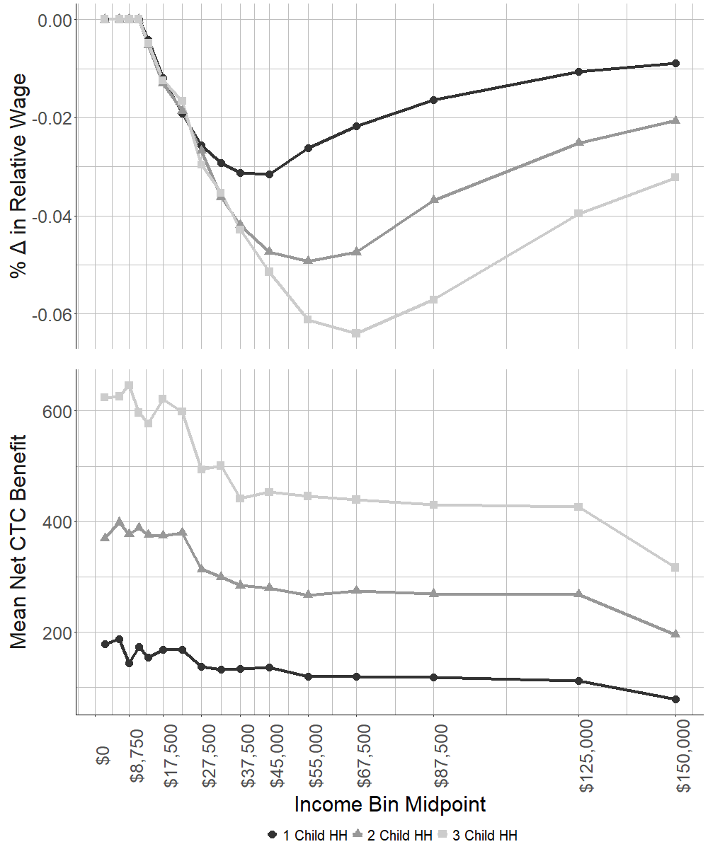

Figure 2: Trends in Employment and Labor Force Participation by Presence of Child and Income Group from January 2021 to February 2022, Current Population Survey
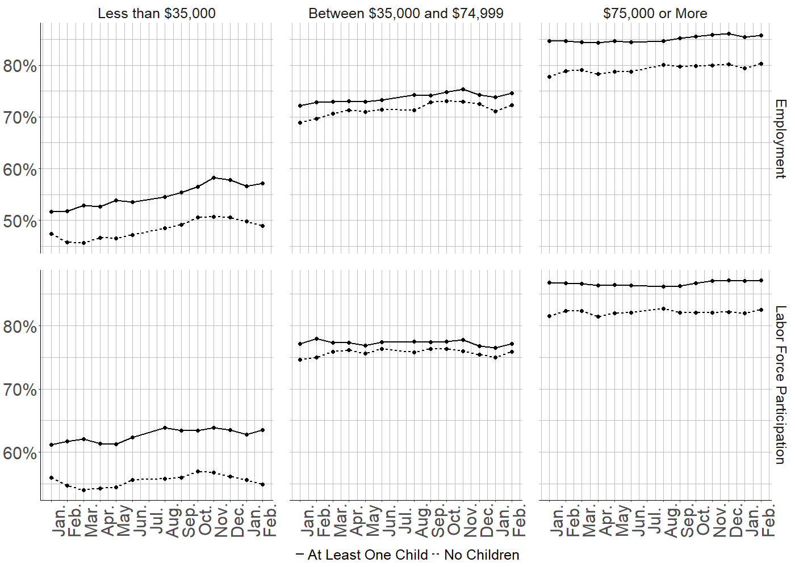
Note: This figure presents both the employment and labor force participation rates from the monthly CPS among respondents between the ages of 18 and 65 from January 2021 to February 2022. These rates are split between childless households and those with at least one child present in the household, as well as three income groups, those with household incomes less than $35,000, those with household incomes between $35,000 and $74,999, and those with household incomes greater than or equal to $75,000.

Figure 3: Heterogeneous Effects by Income Bin (U.S. Current Population Survey, January 2021 - February 2022)
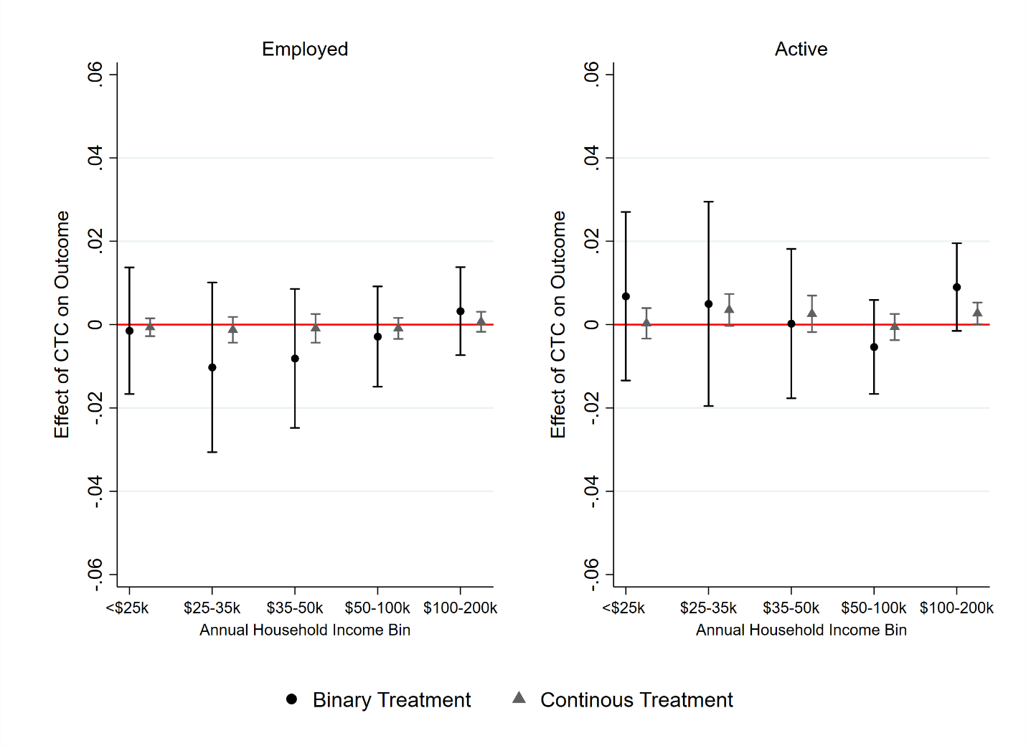
Note: Continuous treatment indicator represents the effect of a $100 net increase in monthly benefit value.

Figure 4: Heterogeneous Effects by Demographic Group (U.S. Current Population Survey, January 2021 – February 2022)

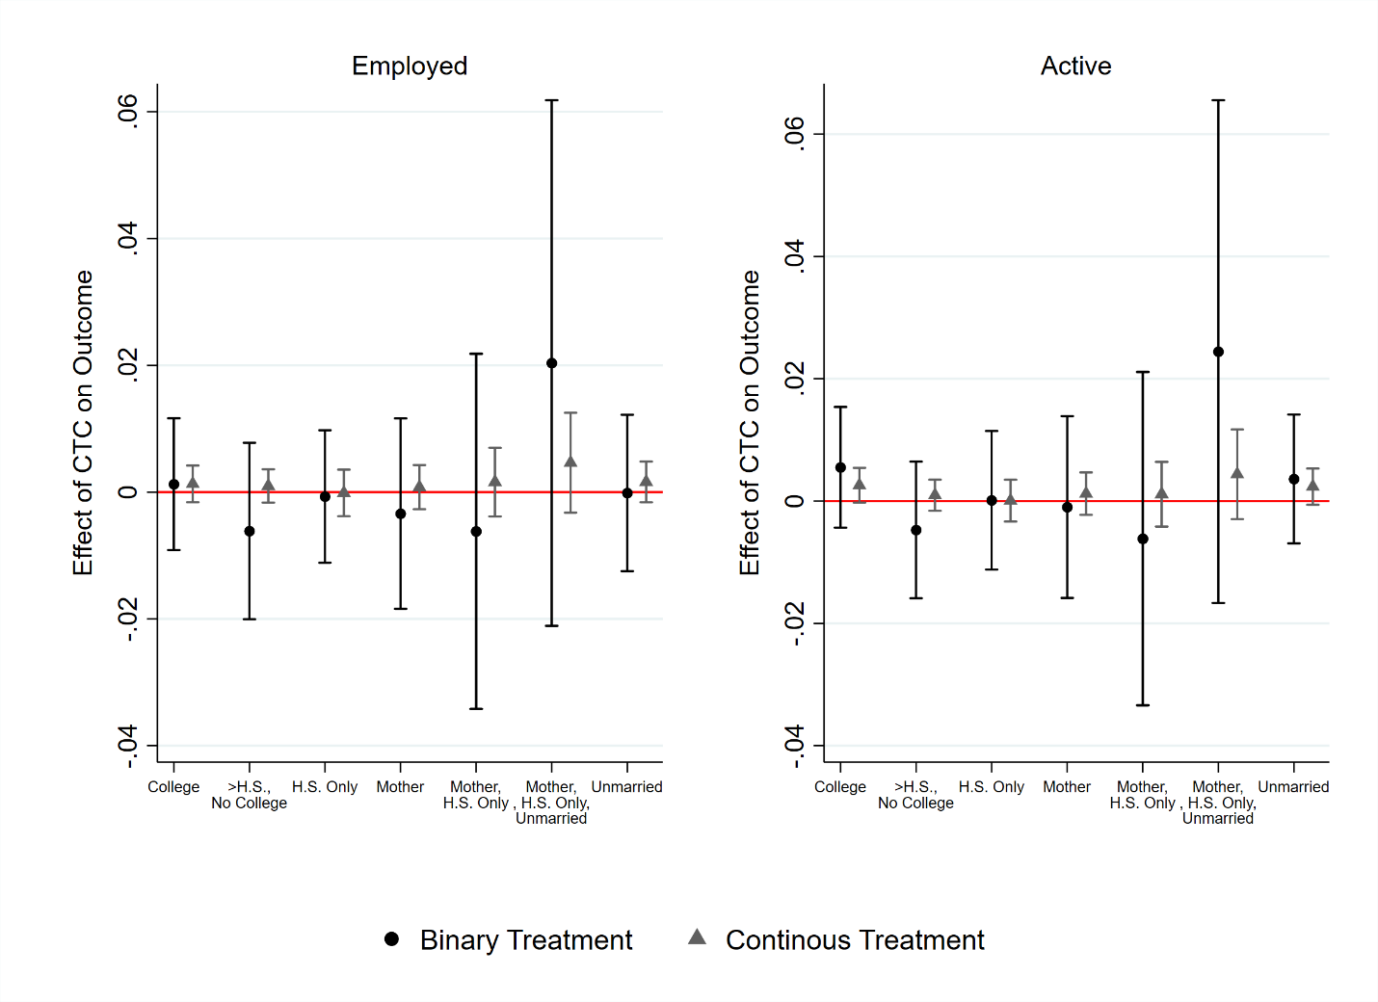
Note: H.S. = High School Degree. Continuous treatment indicator represents the effect of a $100 net increase in monthly benefit value.

Figure 5: Event Study on the Effect of the CTC Expansion using both the March 15th and July 15th Treatment Definitions (U.S. Current Population Survey, January 2021 – February 2022)

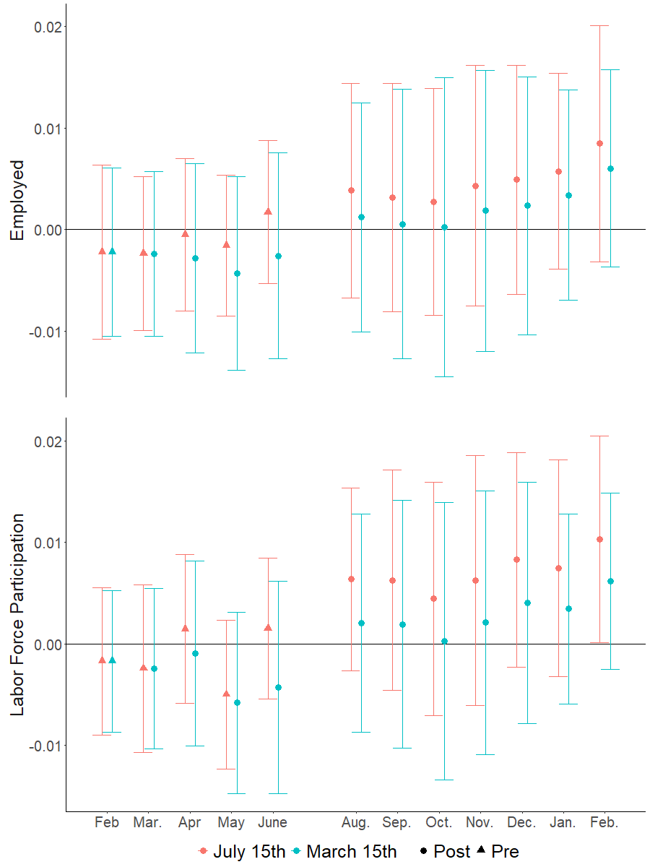
Note: Event study using the Callaway and Sant’Anna (2021) methodology and binary treatment definition; includes controls for age, sex, and education. Each point represents that month’s treatment effect, both pre-and post-treatment, and includes a 95% confidence interval using robust standard errors clustered at the state level.

Figure 6: Difference-in-differences Estimates of the Effect of the CTC Expansion on Employment Outcomes Using the Callaway and Sant’Anna (2020) methodology and defining treatment group by the additional monthly CTC payment received. (CPS, January 2021 through February 2022)

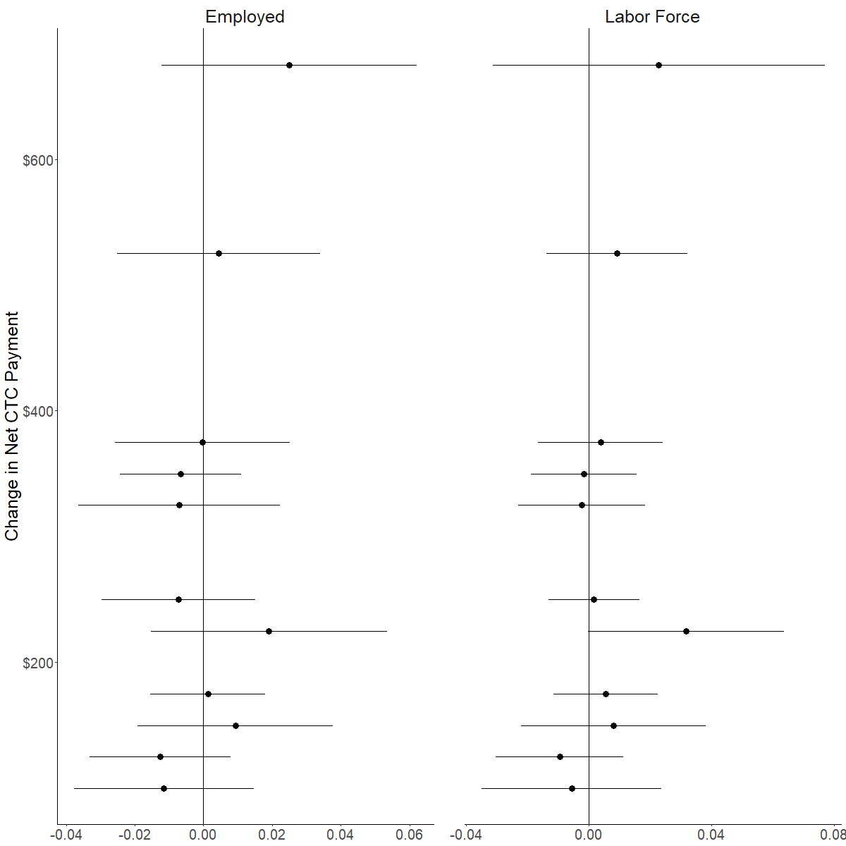

Note: Sample: adults between ages 18–65. All models include controls for age, education, and sex of household head. Each treatment group is defined by the additional monthly CTC payments as a result of the CTC expansion– rounded to the nearest $25. Presented treatment groups are those with at least 1% of the sample. The figure shows the point estimate and 95% confidence interval using robust standard errors clustered at the state level.

Figure 7: Difference-in-differences estimates of the effect of the CTC expansion on employment outcomes using the Callaway and Sant’Anna (2020) methodology and defining treatment group by the number and age of children. (CPS, January 2021 through February 2022)

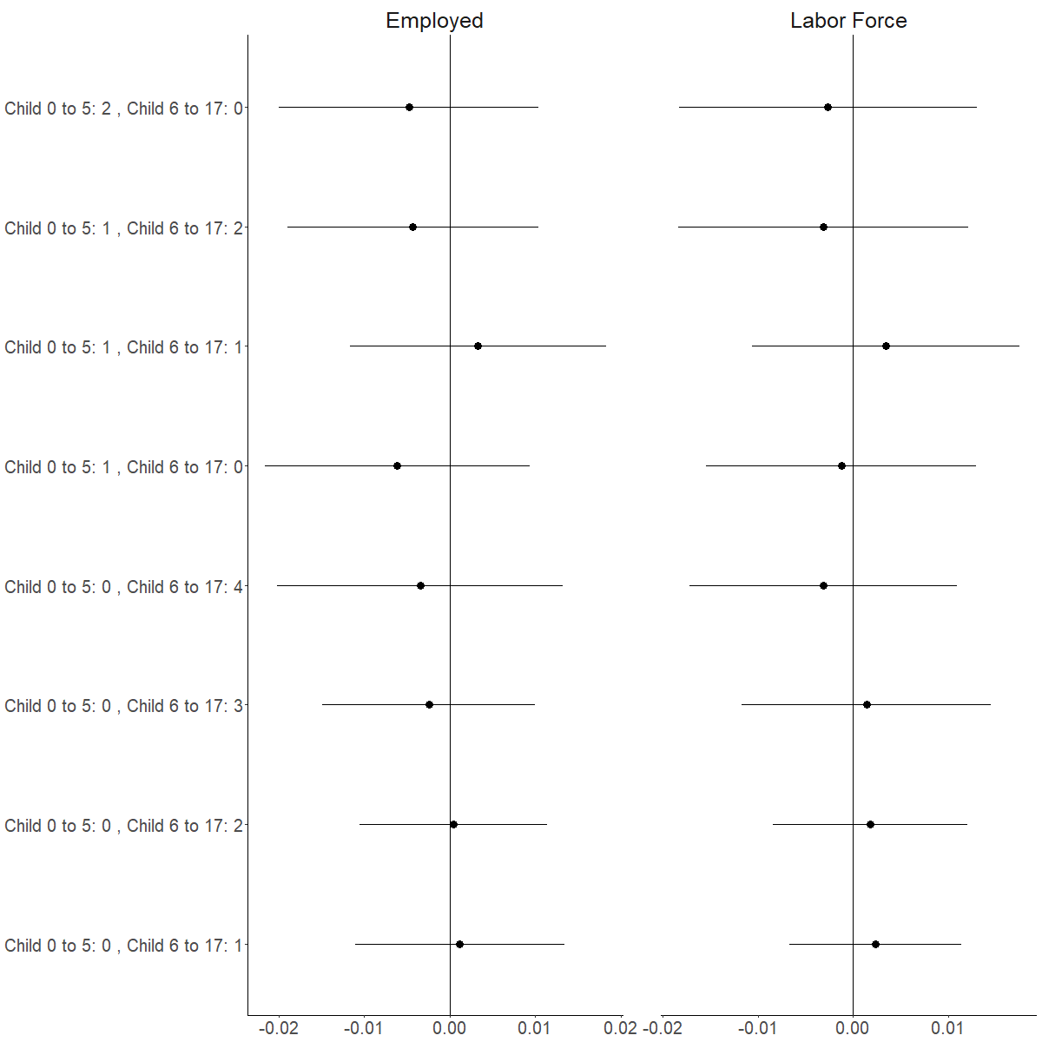
Note: Sample: adults between ages 18–65. All models include controls for age, education, and sex of household head. Each treatment group is defined by the number and age of children in the houshold. Presented treatment groups are those with at least 1% of the sample. The figure shows the point estimate and 95% confidence interval using robust standard errors clustered at the state level.

Figure 8: Difference-in-differences estimates of the effect of the CTC expansion on employment outcomes using the Callaway and Sant’Anna (2020) methodology and defining treatment group by the change in the relative wage. (CPS, January 2021 through February 2022)
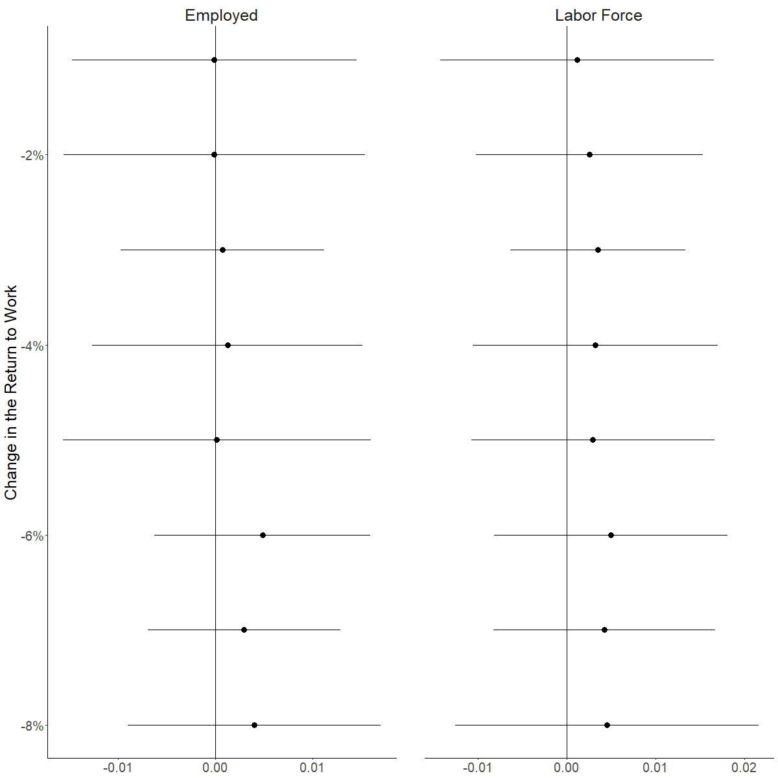
Note: Sample: adults between ages 18–65. All models include controls for age, education, and sex of household head. Each treatment group is defined by the change in the relative wage as a result of the CTC expansion.. Presented treatment groups are those with at least 1% of the sample. The figure shows the point estimate and 95% confidence interval using robust standard errors clustered at the state level.

ONLINE APPENDIX

Table A1: Descriptive Statistics for the Household Pulse Survey
 | Pulse
 | Mean | St. Dev.
Employment rate | 0.689 | 0.463
Labor force participation rate | - | -
Age | 43.44 | 12.99
Percent female | 0.515 | 0.5
Household size | 2.66 | 1.44
Number of children | 0.672 | 1.08
N | 818,009
Note: Sample: adults between ages 18–65 in the Household Pulse Survey.

Table A2: Difference-in-Differences Estimates of the Effect of Expanded CTC on Employment Outcomes (U.S. Census Household Pulse Survey, January 6, 2021 through February 7, 2022)
 | Jan 2021 – Feb 2022  (Treatment Off, On, and Off) | Jan 2021 – Dec 2021  (Treatment Off and On)
Binary Treatment | 1: Employed  (Intent to Treat) | 3: Employed  (Intent to Treat)
Household with Children | 0.006 | 0.007
 | (0.004) | (0.005)
Household with Children X Post-July 15 | 0.004 | 0.003
 | (0.006) | (0.007)
Continuous Treatment | 1: Employed  (Intent to Treat) | 3: Employed  (Intent to Treat)
Household with Children | -0.009 | -0.008
 | (0.005) | (0.005)
Household with Children X Post-July 15 | 0.002 | 0.001
 | (0.001) | (0.001)
Pre-Treatment Mean among Households with Children | 0.686 | 0.686
Observations | 818,009 | 723,545
Note: Sample: adults between ages 18–65. All models include state and week fixed week effects and control for age, education, and sex. Treated period refers to July 15, 2021, through December 31, 2021. Robust standard errors clustered at the state level in parentheses. * p < 0.05, ** p < 0.01, *** p < 0.001.

Table A3: Difference-in-Differences Estimates of the Effect of the Change in Relative Wage on Employment Outcomes (Current Population Survey, January 2021 through February 2022. U.S. Census Household Pulse Survey, January 6, 2021 through February 7, 2022)
 | Pulse
 | 3: Employed
% Change in Relative Wage | -0.958***
 | (0.089)
% Change in Relative Wage X Post-July 15 | -0.073
 | (0.091)
Pre-Treatment Mean among Households with Children | 0.761
Observations | 818,009
Note: Sample: adults between ages 18–65. All models include state and week (Pulse) fixed effects and controls for age, education, and sex. Treated period refers to July 15, 2021, through December 31, 2021. Robust standard errors in parentheses clustered at the state level. * p < 0.05, ** p < 0.01, *** p < 0.001.

Table A4: Full Interactions: Difference-in-Differences Estimates of the Effect of Expanded CTC on Employment Outcomes with Controls Interacted with Treatment and Time Dummies (U.S. Census Household Pulse Survey, January 6, 2021 through February 7, 2022)
 | Jan 2021 – Feb 2022  (Treatment Off, On, and Off) | Jan 2021 – Dec 2021  (Treatment Off and On)
Binary Treatment | 1: Employed  (Intent to Treat) | 3: Employed  (Intent to Treat)
Household with Children | -0.094*** | -0.087***
 | (0.009) | (0.011)
Household with Children X Post-July 15 | 0.002 | 0.001
 | (0.006) | (0.007)
Continuous Treatment | 1: Employed  (Intent to Treat) | 3: Employed  (Intent to Treat)
Household with Children | -0.025** | -0.022**
 | (0.008) | (0.008)
Household with Children X Post-July 15 | 0.001 | 0.000
 | (0.001) | (0.001)
Pre-Treatment Mean among Households with Children | 0.686 | 0.686
Observations | 818,009 | 723,545
Note: Sample: adults between ages 18–65. All models include state and week (Pulse) fixed effects and controls for age, education, and sex. Treated period refers to July 15, 2021, through December 31, 2021. Robust standard errors in parentheses clustered at the state level. * p < 0.05, ** p < 0.01, *** p < 0.001.

Figure A1: Share of children in households reporting receipt of monthly Child Tax Credit payment (Census Household Pulse Survey, July 2021 to December 2021)
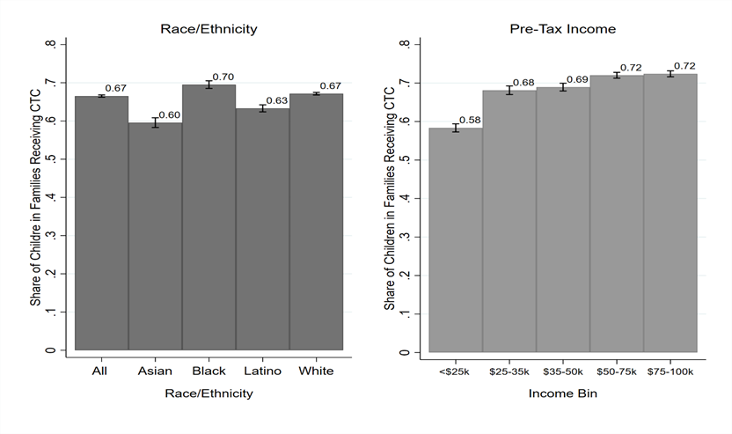

Figure A2: Heterogeneous effects by income bin (U.S. Census Household Pulse Survey, January 2021 – February 2022)
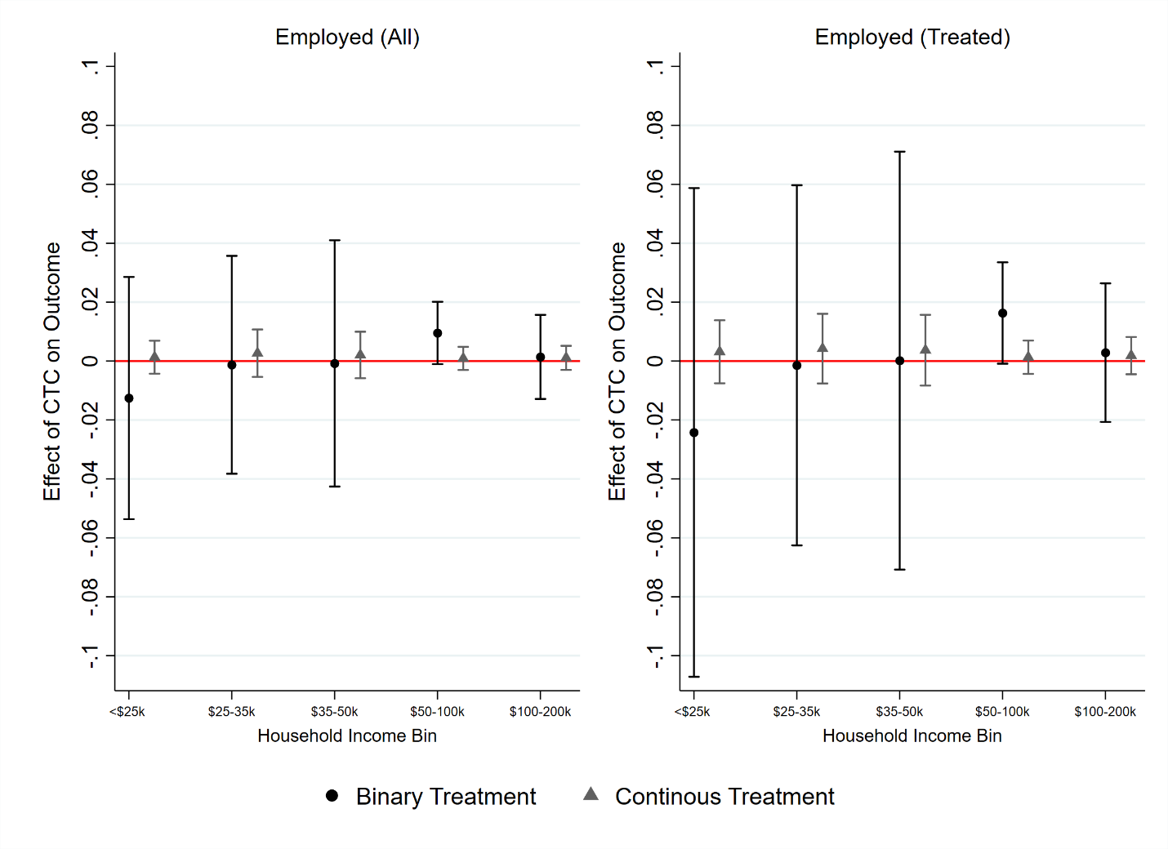
Note: Continuous treatment indicator represents the effect of a $100 net increase in monthly value. Sample: adults between ages 18–65. All models include state and week fixed effects and controls for age, education, and sex. Treated period refers to July 15, 2021, through December 31, 2021. Robust standard errors in parentheses clustered at the state level. * p < 0.05, ** p < 0.01, *** p < 0.001.

For additional information on the history of the Child Tax Credit, see Crandall-Hollick (2021), Crandall-Hollick (2018), and Garfinkel et al. (2016).
The expansion to the CTC in the ARP mirrors the proposed reforms in the American Family Act (AFA) with one exception: in the AFA, the credit would begin to phase out for heads of household with earnings above $120,000 or and joint filers with Adjusted Gross Incomes (AGI) over $180,000. In the ARP, the credit began to phase out for families with AGIs above $112,500 or $150,000 per year, depending on filing status, but it only phased out until matching the credit values that a family would receive under prior law. This alteration was made because the Biden administration committed to not raising taxes for those with incomes below $400,000 per year.
Because the payments began halfway through the year, families received half of the full amount of their credit in 2021 and the remainder after filing their 2021 taxes in 2022.
Following convention, we define a change in the work subsidy as a change in the implicit marginal tax rate (MTR) on work. While the 2021 policy weakly decreased the average tax rate (ATR) for all families, it increased the MTR on work for families who received the prior CTC, and especially for those who were in the phase-in range of the prior CTC (see Figure 1, discussed below).
It is possible that instead the increase in cost of working due to COVID risks and school/care closures moved more otherwise marginal workers into non-work than moved otherwise consistent workers into marginal work, such that the parent population overall became less rather than more responsive to the return to work and therefore the population-level short-term compensated price elasticity fell instead of rose during COVID. However, given that most parents work (see Figure 2), that possibility requires an unconventional (e.g. bimodal) distribution of the costs of working.
The fact that the 2021 CTC was distributed monthly rather than annually, unlike the EITC and the previous version of the CTC, could increase salience and reduce lag-time in responses to incentives relative to those programs.
In a sensitivity test, we have also evaluated the results when adjusting the benefits for household size using the modified OECD equivalent scale. The OECD scale begins with a value of 1 for a single adult, then adds 0.5 for each child in the home and 0.3 for each additional adult in the home. The results are not meaningfully different from our primary findings.

